Task on Load Balancers
- Configure Classic Load balancer.
A Classic Load Balancer (CLB) is an AWS load balancer that distributes incoming traffic across multiple EC2 instances, improving high availability and fault tolerance. It automatically sends requests only to healthy instances using health checks.
- EC2 → Load Balancers → Create Load Balancer → Classic Load Balancer
  - Enter Name, select Internet-facing, choose IPv4.
Internet-facing: Allows users to access the application from the internet.
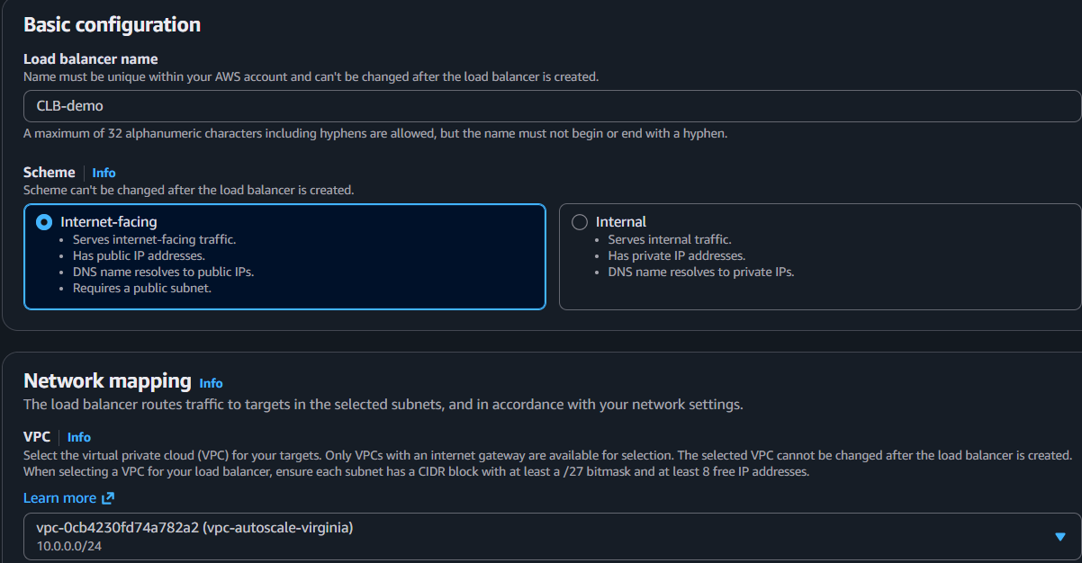
- Select VPC and 2 Public Subnets
Public Subnets (2 AZs): Provides high availability if one Availability Zone fails.
- Configure Listener
  - HTTP : 80 → HTTP : 80
Listener: Receives client requests and forwards them to EC2 instances.
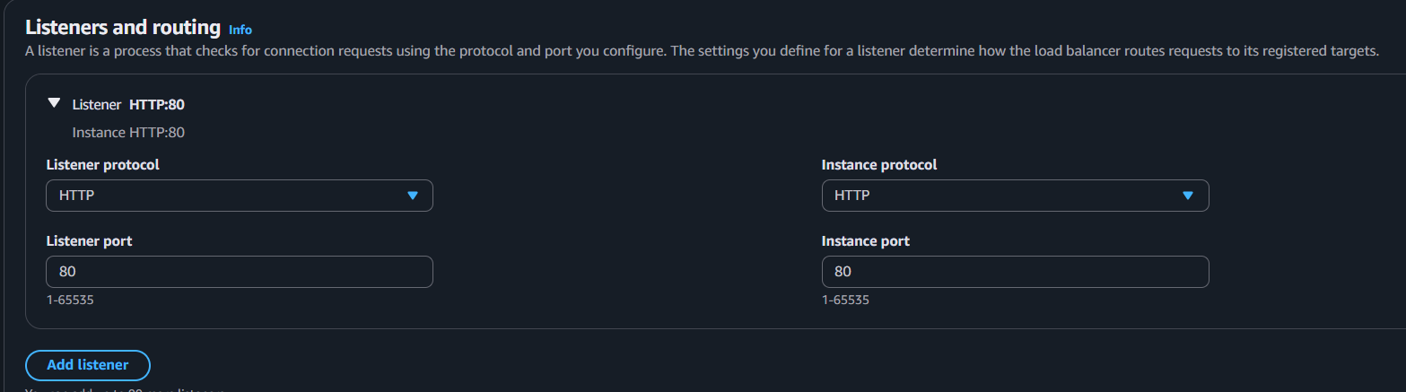
- Select Security Group
  - Allow HTTP (80).
Security Group: Acts as a firewall for the load balancer.
- Configure Health Check
  - HTTP, Port 80, Path /
Health Check: Sends traffic only to healthy EC2 instances.
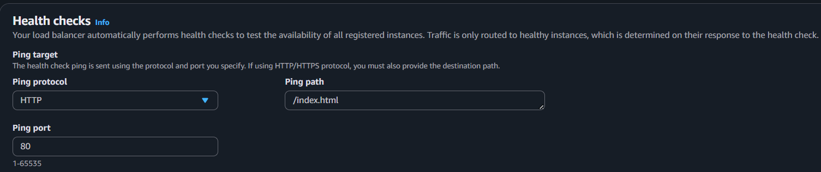
- Register EC2 Instance → Review → Create
Registered Instances: Backend servers that receive traffic from the load balancer.
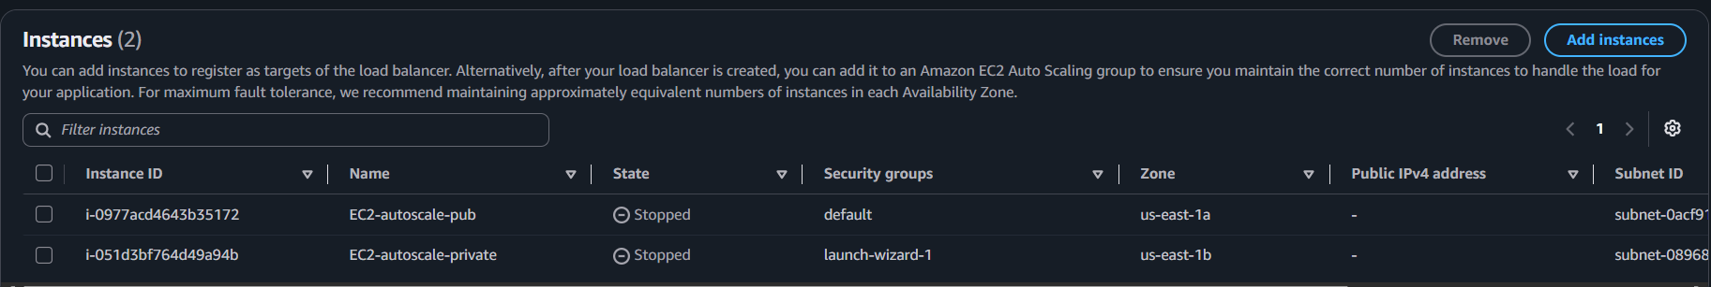
- Copy the CLB DNS Name and test it in a browser.
DNS Name: Public endpoint used to access the application.

- Configure Application Load balancer.
- EC2 → Load Balancers → Create Load Balancer → Application Load Balancer
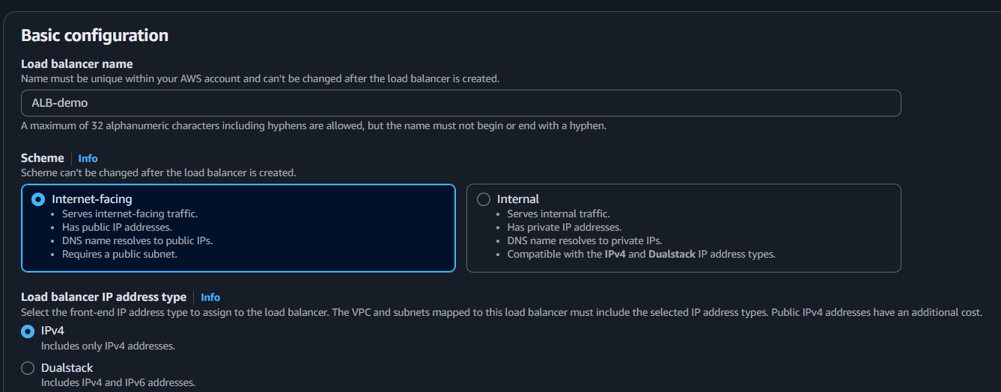
  - Enter Name, choose Internet-facing (public access), select IPv4.

- Select VPC & 2 Public Subnets (2 AZs)
  - Deploys the ALB across multiple Availability Zones for high availability.
- Configure Security Group & Listener
  - Security Group: Allow HTTP (80).
  - Listener: HTTP (80) receives client requests.
- Create or Select a Target Group
  - Choose Target type: Instances.
  - Protocol: HTTP, Port: 80.
  - Register your EC2 instance(s).
  - The Target Group manages and monitors the backend EC2 instances.
- Review & Create
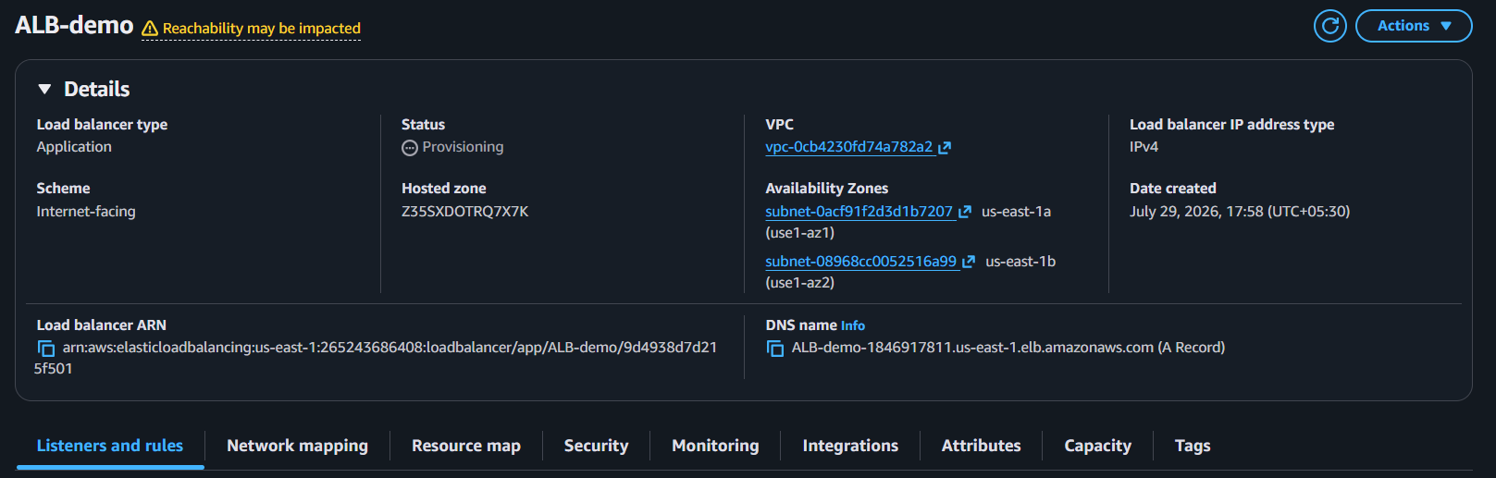
  - Review the configuration and click Create Load Balancer.

- Test the ALB
  - Open the ALB DNS Name in a browser to verify the application is accessible.
Result: The Application Load Balancer distributes incoming HTTP requests only to healthy EC2 instances registered in the Target Group.


- Configure Network Load balancer.
- EC2 → Load Balancers → Create Load Balancer → Network Load Balancer
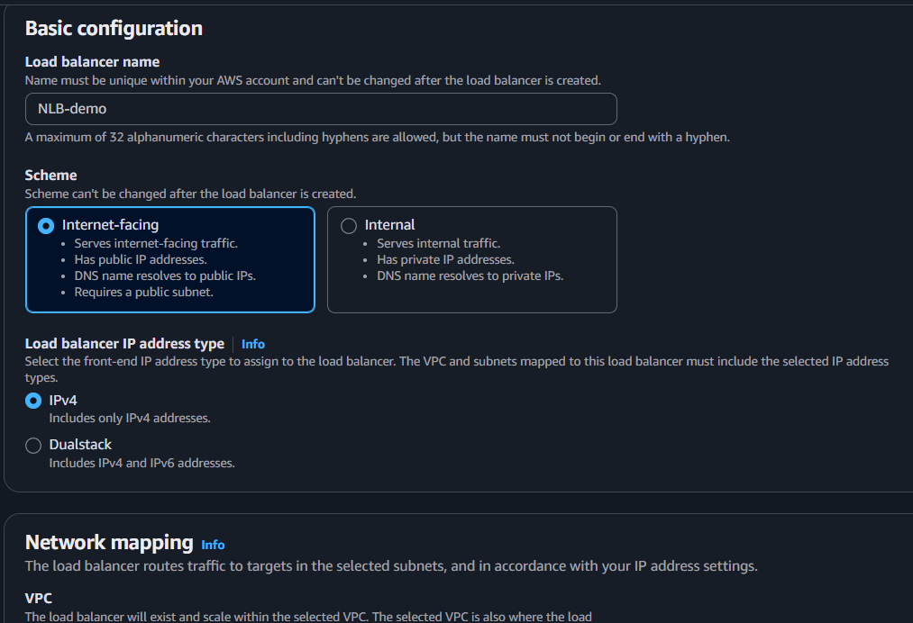
  - Enter Name, choose Internet-facing (public access), and select IPv4.

- Select VPC & 2 Public Subnets (2 AZs)
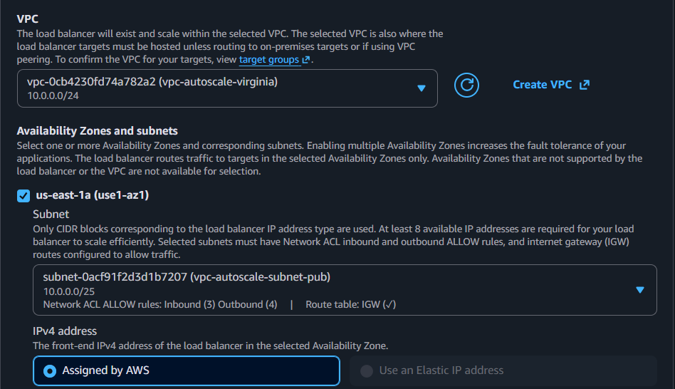
  - Deploys the NLB across multiple Availability Zones for high availability.

- Configure Listener & Security
- Listener: TCP (80) receives network traffic.
- Select or create the required target group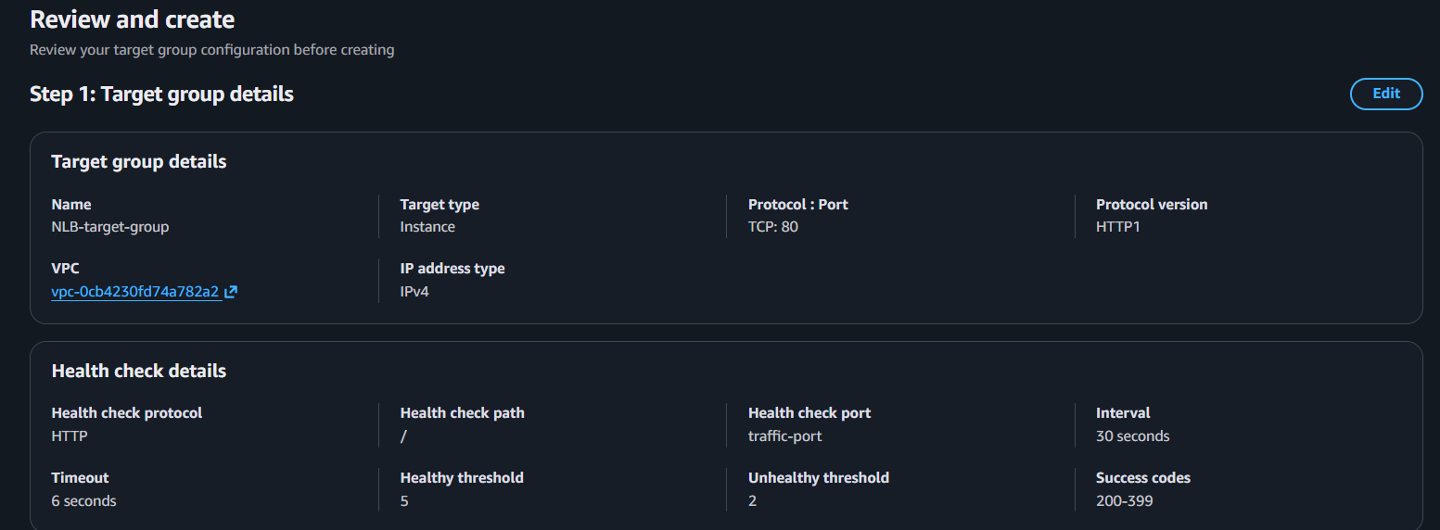
- Create or Select a Target Group
- Target type: Instances.
- Protocol: TCP, Port: 80.
- Register your EC2 instance(s).
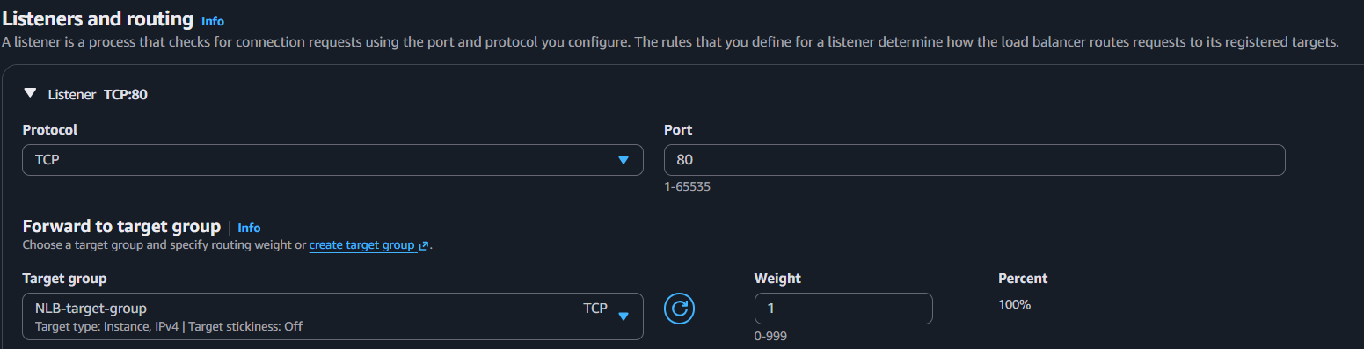
- The Target Group routes traffic to healthy backend instances.

- Review & Create
- Review the configuration and click Create Load Balancer.
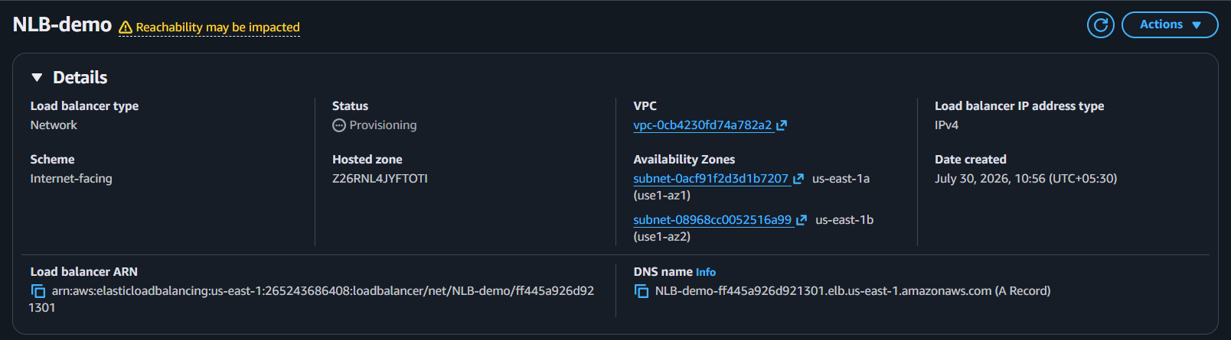
- Test the NLB
- Open the NLB DNS Name in a browser to verify the application is accessible.
Result: The Network Load Balancer distributes TCP/UDP traffic to healthy EC2 instances with high performance and low latency.
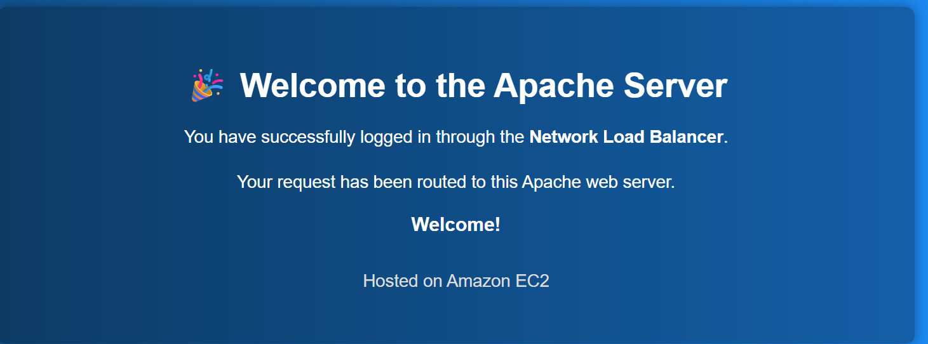

- Attach SSL for application load balancer.
- Request an SSL Certificate
  - Open AWS Certificate Manager (ACM).
  - Click Request → Request a public certificate.
  - Enter your domain name (e.g., example.com or *.example.com).
  - Validate ownership (DNS validation recommended).
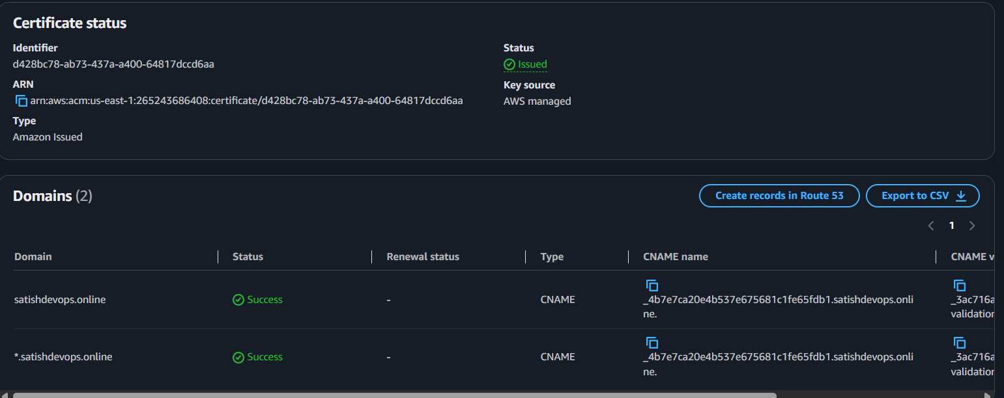
  - Wait until the certificate status is Issued.

- Open the ALB
  - Go to EC2 → Load Balancers.
  - Select your Application Load Balancer.
- Add an HTTPS Listener
  - Go to the Listeners and rules tab.
  - Click Add listener.
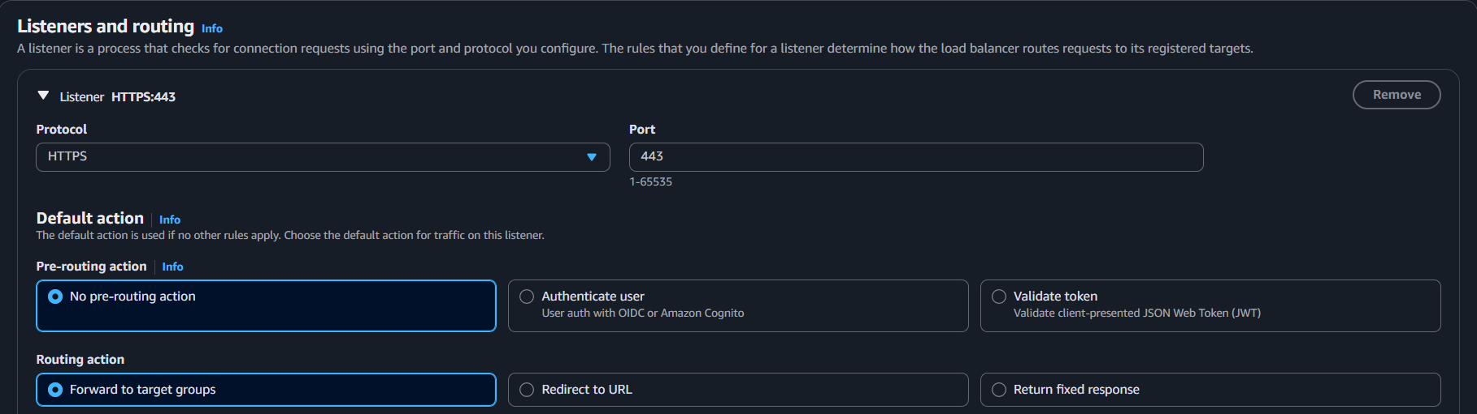
  - Select HTTPS (443).

- Attach the SSL Certificate
  - Under Secure listener settings, choose From ACM.
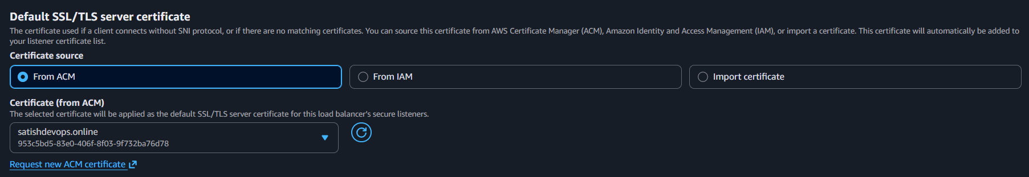
  - Select the issued SSL certificate.

- Configure the Default Action
  - Choose the target group that serves your application.
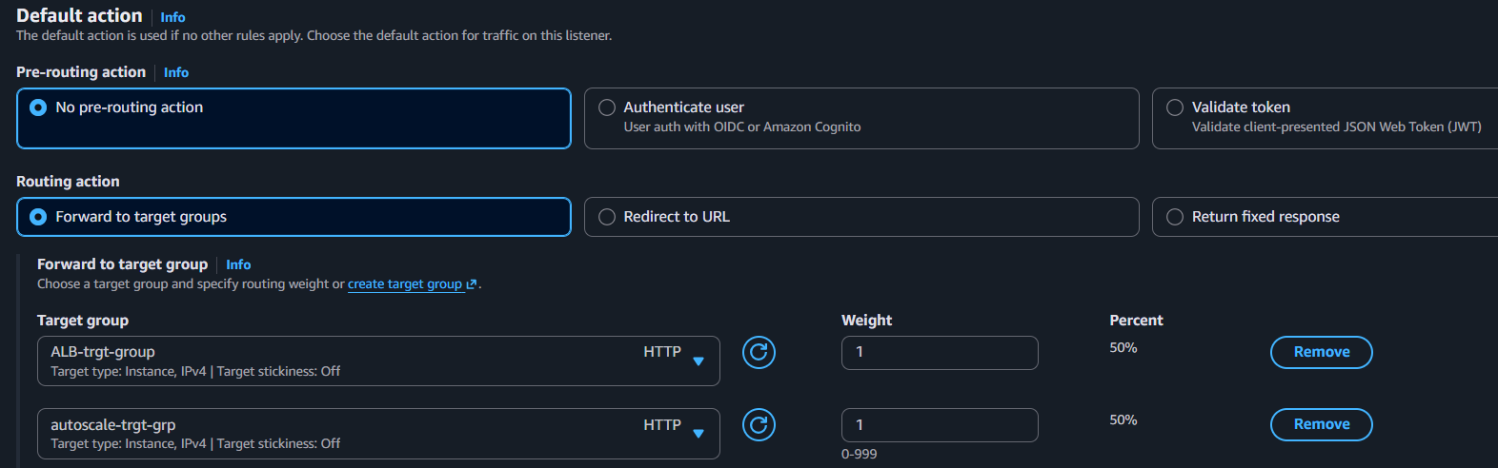
  - Click Add listener or Save.
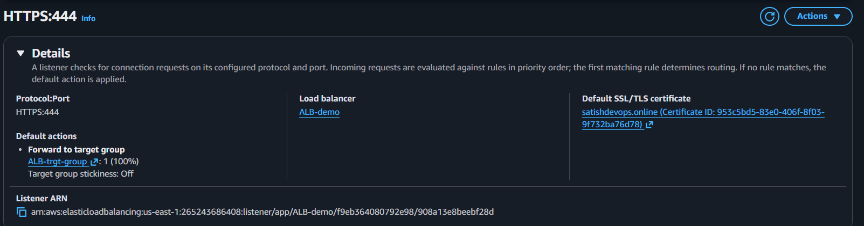

- Map Application load balancer to R53.
- Open AWS Console → Route 53 → Hosted Zones.
- Select your hosted zone (e.g., satishdevops.online).
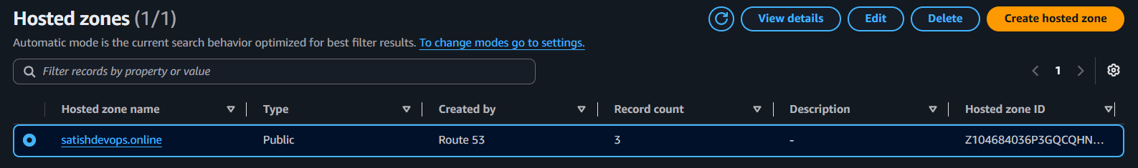
- Click Create record.
- Configure the record:
- Record name: Leave blank (or enter www if needed).
- Record type: A – IPv4 address.
- Alias: Enable.
- Route traffic to: Alias to Application and Classic Load Balancer.
- Region: us-east-1 (N. Virginia).
- Choose Load Balancer: Select your ALB.
- Routing policy: Simple routing.
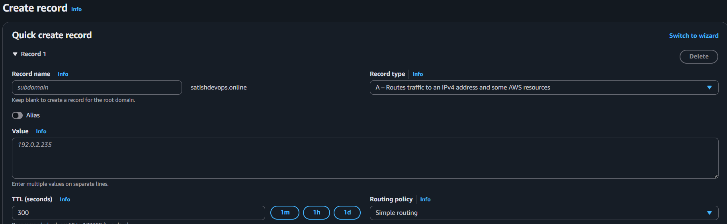
- Click Create records.
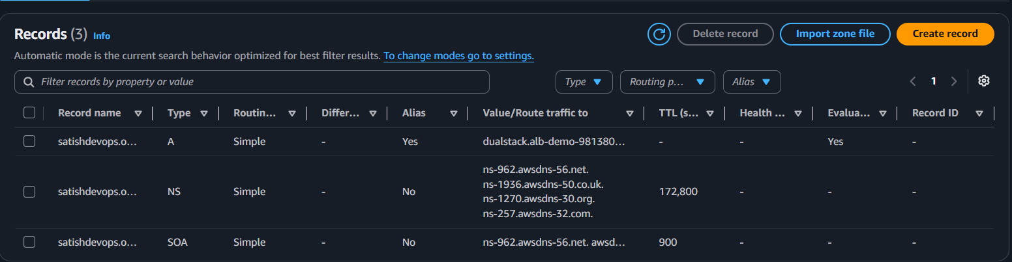
- Wait a few minutes for DNS propagation.
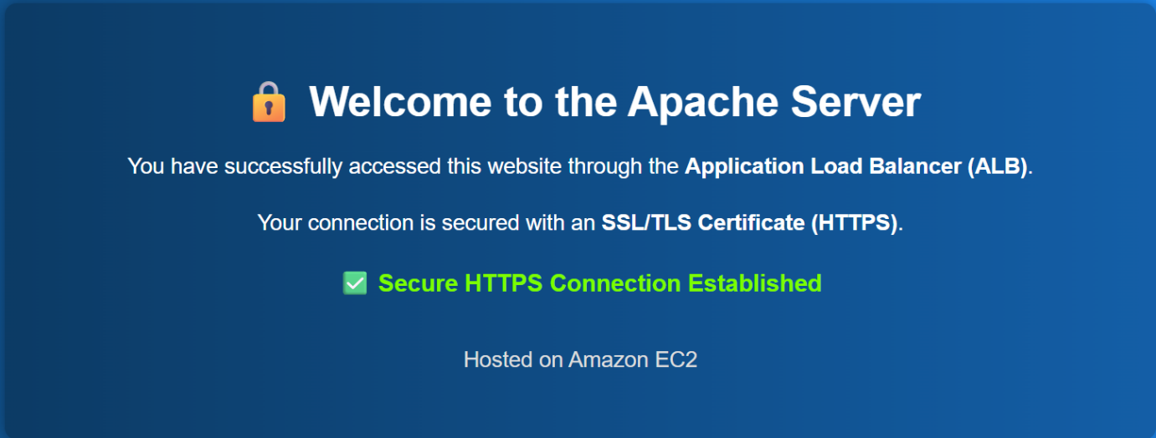
- Test by opening:

- Push the application load balancer logs to S3.
Step :1 Create an S3 Bucket
- Go to S3 → Create bucket.
- Enter a unique bucket name.
- Create the bucket.
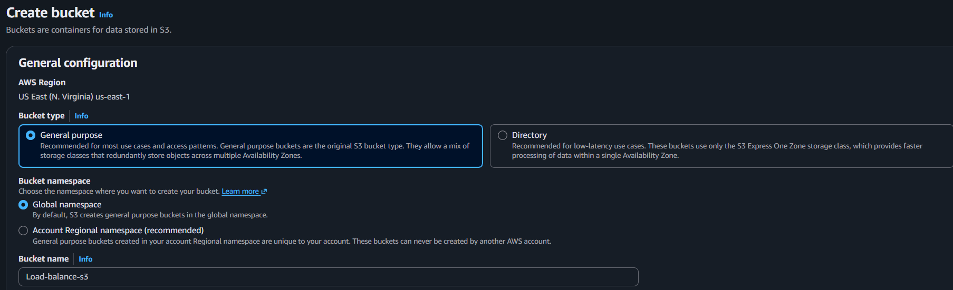
Step:2 Add Bucket Policy
- Open the bucket → Permissions → Bucket Policy.
- Add the AWS-recommended ALB access log policy (replace the bucket name and account ID if needed).
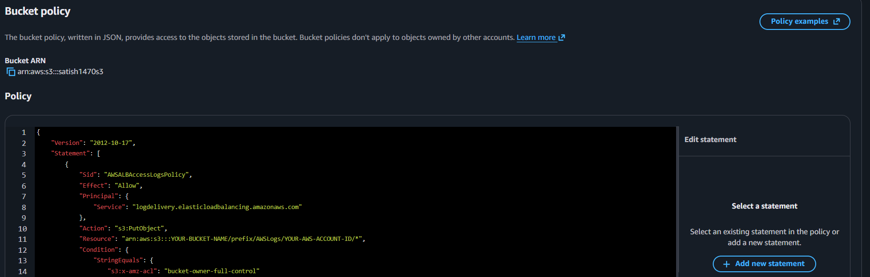
Step:3 Enable Access Logs on ALB
- Go to EC2 → Load Balancers.
- Select your Application Load Balancer.
- Open the Attributes tab.
- Click Edit.
Step:4 Enable Logging
- Enable Access logs.
- Select your S3 bucket.
- (Optional) Enter a prefix (e.g., alb-logs/).
- Click Save changes.
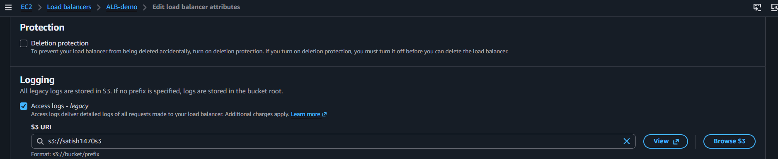
Step:5 Generate Traffic
- Open your website through the ALB several times:
https://satishdevops.online
Step:6 Verify Logs
- Go to S3 → Your Bucket.
- Open the prefix (if configured).
- Confirm that ALB log files have been created.
